【Battery installation method】
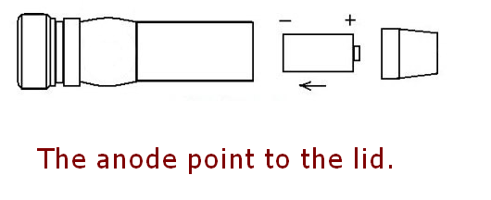

【Operating Instruction】
[Press hard]
Power ON / Power Off

[Press gently]
(When the power on)
High Light / Low Light / Glitzy Light
The replacement cycle between 3 modes.

【Important Warning】
(Self-defence feature)
When you use the self-defence feature, make sure according to below items.
1. Set the laser spot to big size.
(When the laser spot is a small dot pointer, the laser beam is very dangerous for human eyes.)
2. Use the glitzy model. (Not blaze light )
3. Don't use this feature in the close distance.

Never shot the eyes directly!!!

